Little SPARK: Simple Play Adaptations to Reference for Kids

Spiky Tactile Ball
Description: | Image:
Blue colored five inch textured ball made of PVC weighs 3 oz.  Purchasing Information | 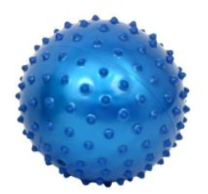

Who Might Benefit?
For those who need support with self-regulation, sensory input, or focus through fidgeting, or seeking tactile engagement to calm themselves or maintain attention.
Why Use?
Self-regulation, quiet self-calming activities, tactile exploration of the spiky ball, improved eye-hand coordination, and focused fidgeting.
Instructions for Use: | Adaptation Ideas:
Environmental Considerations  - Use in all settings and in group and one-on-one activities.  Positioning  - Use in any position; seated, standing, on the floor, etc.  Basic Play/Use  - Open ended exploration (ex. touch, roll, squeeze).  Play/Use with Others  - Take turns catching, playing basketball, or bowling. | Stabilize It  - Construct a handle or Velcro to surface  Contain It  - Place ball in open container or sensory bin.  Add Sensory Cues  - Store in sensory tub with other items.  Communication Supports  - Visual supports like communication cards and social narratives can help a child communicate their feelings.  Alternative Uses  - Use like a talking stick during circle or sharing time.  - Play hot potato.  DIY Alternatives  - Inexpensive textured ball from discount or pet store.  - Bean bags or squeeze balls with various textures.

Words to Encourage Play/Use
Touch   | Toss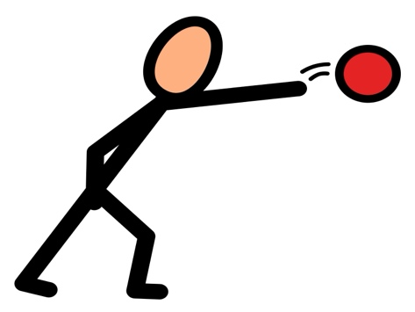 | Roll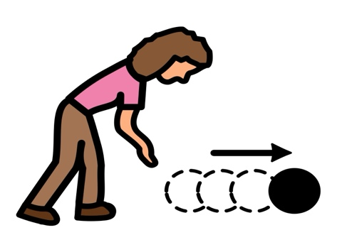
Push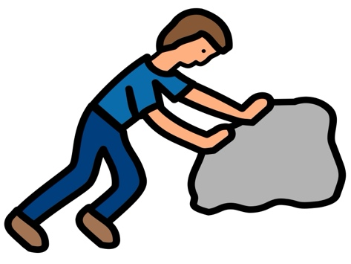 | In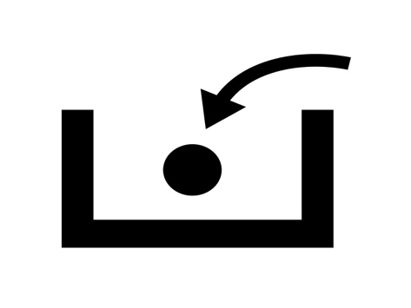 | Out
Catch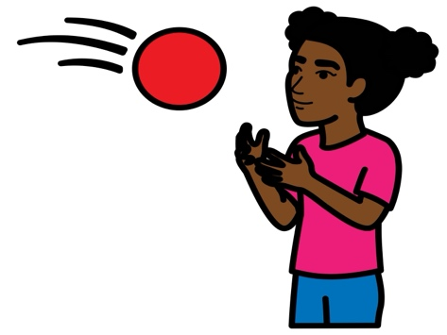 | Quiet | Calm  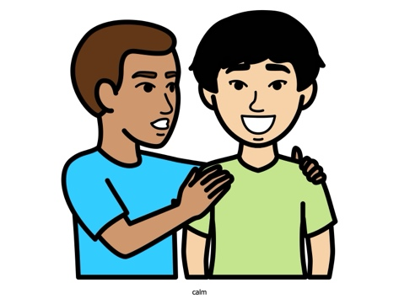
*”Adaptations” adapted from: Haugen’s Modes for Adapting Toys based on materials from the "Let's Play" Project at the University of Buffalo
PCS is a trademark of Tobii Dynavox, LLC. All rights reserved. Used with permission.

